Technical Specification

Scanning project

Author: Mr. Rosen Rusev

Date: 2014-09-05

Version: 1.0

# Document Control

**Document location**

| Location |
| --- |
|  |

**Author**

| Position | Name | Contact no |
| --- | --- | --- |
| Senior C# developer | Mr. Rosen Rusev | +442035304037 |

**Revision history**

| Version | Issue date | Author/editor | Description/Summary of changes |
| --- | --- | --- | --- |
| V1.0 | 05/09/14 | Rosen Rusev | Document Creation |
|  |  |  |  |

**Reviewed by**

| Version | Issue date | Name | Position | Review date |
| --- | --- | --- | --- | --- |
|  |  |  |  |  |
|  |  |  |  |  |
|  |  |  |  |  |

**Approvals**

| Version | Issue date | Name | Position | Approval date |
| --- | --- | --- | --- | --- |
|  |  |  |  |  |
|  |  |  |  |  |

**Related documents**

| Document | Location |
| --- | --- |
|  |  |

# Table of Contents

1 INTRODUCTION 4

1.1 Objectives 4

1.2 Scope 4

2 Functionality 4

2.1 Use Case Diagram 4

3 Achitecture 4

3.1 Architecture Overview 4

3.2 Component Structure 5

3.3 Application Interfaces 5

4 Design 6

4.1 Object Diagram 6

4.2 Entity Relationship Diagram 9

4.3 Other Components 9

5 CODE 9

5.1 ColdFusion File Names and Structure 9

5.2 Executable File Names and Structure 10

5.3 Database Scheme Structure 12

# INTRODUCTION

## Objectives

The project is for scanning, signing, storing, searching and showing voucher images.

## Scope

The project will consist of creating and deploying scanning system among the countries. The project will be completed by 2016-01-01.

# Functionality

System stores images centralized. It allows all users to upload and download images. It also provides ability external, third part companies to access the images. System applies security policies and protects the images.

## Use Case Diagram

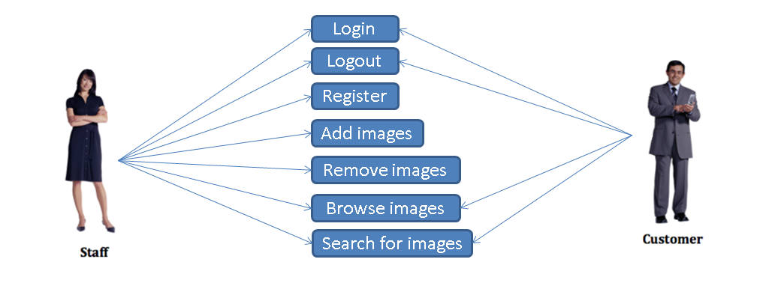

# Achitecture

## Architecture Overview

System contains following modules:

* Windows scanning station
  + Scans vouchers by scanning device
* Windows picture taking (camera) application
  + Take picture of vouchers during data entry process
* MVC web site showing images for internal use
  + Search and shows vouchers. For internal personnel only.
* MVC web site for external (third party clients use)
  + Search and shows voucher images. For external customers
* TRS (AX) integration modules.
  + Other systems integrating modules

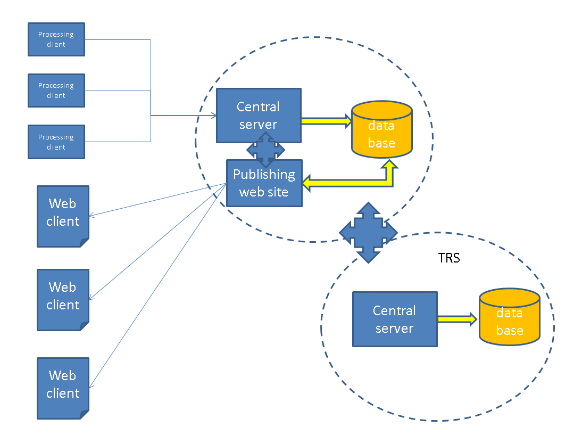

## Component Structure

* Windows scanning station – dedicated scanning station for scanning vouchers.
* Windows picture taking station – station for taking pictures of vouchers.
* Internal MVC web site - MVC web site for internal customers.
* External MVC web site – MVC web site for external customers.
* TRS (AX) integration modules.

## Application Interfaces

* Image upload
* Image download
* Image search
* Image delete
* Image showing
* Image processing
* Picture taking
* Image storing

# Design

## Object Diagram

1. *VPrint class diagram*

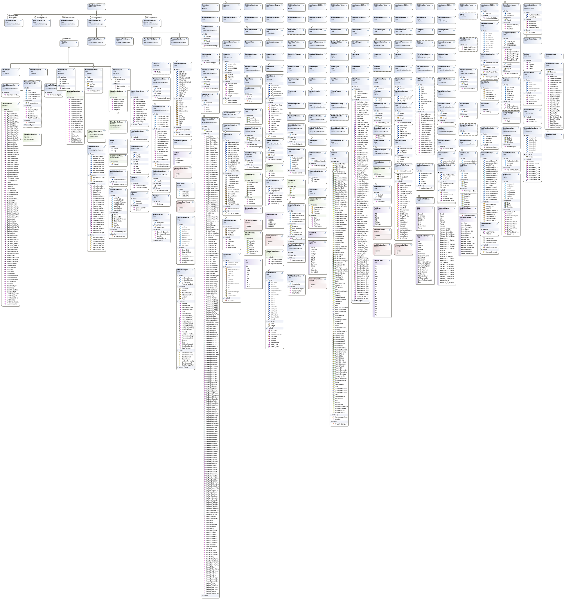

1. *Fintrax receiving service diagram*

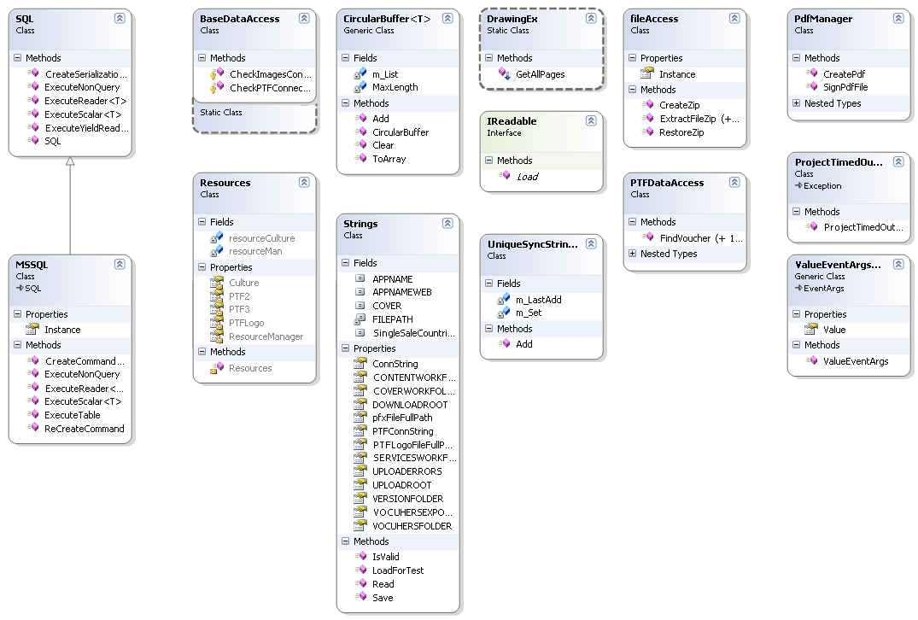

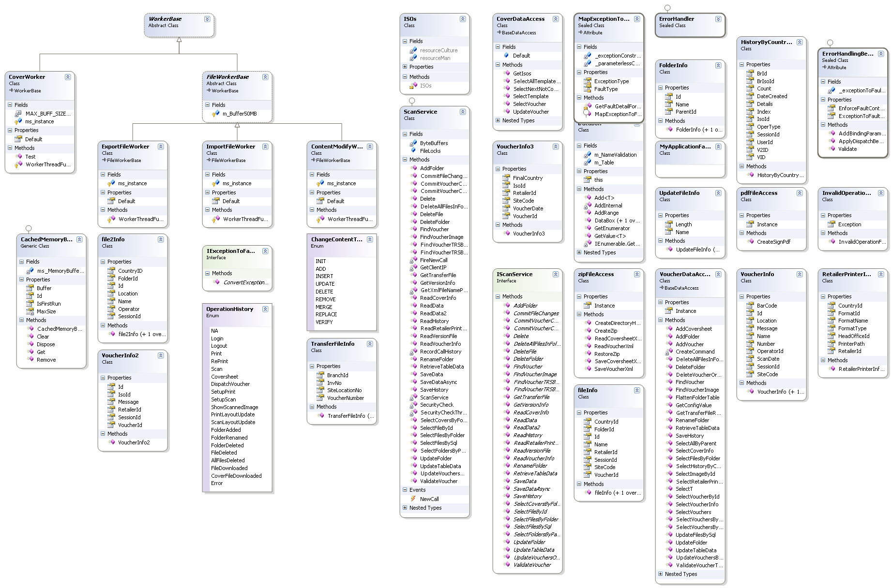

1. *Fintrax images MVC web site*

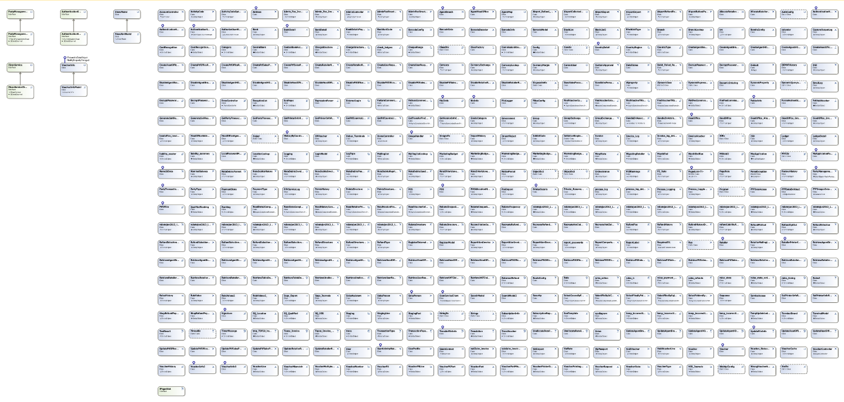

## Entity Relationship Diagram

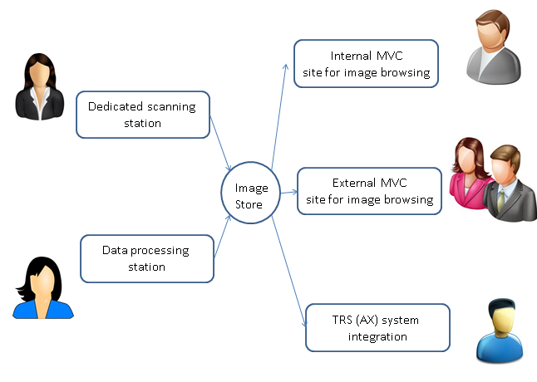

## Other Components

There are next external components involved in the project.

Emgu.CV- open source SDK for computer vision, face detection and image processing.  
AForge – open source for image processing.

Ionic.Zip – open source for archive processing.

DTK.BarReader – license software for barcode reading.

Zen.Barcode.Core – open source for barcode drawing.

# CODE

## ColdFusion File Names and Structure

*VPrint.cfc*

*VPrint.Common.cfc*

*VPrint_addon.cfc*

*FintraxPTFImages.cfc*

*ReceivingService.cfc*

*ReceivingServiceLib.cfc*

*ReceivingServiceLib.Common.cfc*

*ReceivingServiceLib.Drawing.cfc*

*CPrint2.cfc*

*PTF.Common.cfc*

## Executable File Names and Structure

1. *VPrint files*

*VPrint.exe*

*AForge.dll*

*AForge.Imaging.dll*

*AForge.Math.dll*

*DTK.BarReader.dll*

*Ionic.Zip.dll*

*PTF.Common.dll*

*System.Web.Extensions.dll*

*System.Web.Razor.dll*

*VPrint.Common.dll*

*VPrint_addon.dll*

*Zen.Barcode.Core.dll*

1. *CPrint2 files*

*CPrint2.exe*

*AForge.Controls.dll*

*AForge.dll*

*AForge.Imaging.dll*

*AForge.Imaging.Formats.dll*

*AForge.MachineLearning.dll*

*AForge.Math.dll*

*AForge.Video.dll*

*FreeImageNET.dll*

*FreeImage.dll*

1. *FintraxPTFImages*

*Antlr3.Runtime.dll*

*BundleTransformer.Core.dll*

*BundleTransformer.WG.dll*

*DotNetOpenAuth.AspNet.dll*

*DotNetOpenAuth.Core.dll*

*DotNetOpenAuth.OAuth.Consumer.dll*

*DotNetOpenAuth.OAuth.dll*

*DotNetOpenAuth.OpenId.dll*

*DotNetOpenAuth.OpenId.RelyingParty.dll*

*EntityFramework.dll*

*FintraxPTFImages.dll*

*GridMvc.dll*

*Microsoft.Web.Infrastructure.dll*

*Microsoft.Web.WebPages.OAuth.dll*

*Newtonsoft.Json.dll*

*System.Net.Http.dll*

*System.Net.Http.Formatting.dll*

*System.Net.Http.WebRequest.dll*

*System.Web.Helpers.dll*

*System.Web.Http.dll*

*System.Web.Http.WebHost.dll*

*System.Web.Mvc.dll*

*System.Web.Optimization.dll*

*System.Web.Razor.dll*

*System.Web.WebPages.Deployment.dll*

*System.Web.WebPages.dll*

*System.Web.WebPages.Razor.dll*

*WebGrease.dll*

*WebMatrix.Data.dll*

*WebMatrix.WebData.dll*

1. *Receiving service*

*ReceivingService.exe*

*Emgu.CV.dll*

*Emgu.Util.dll*

*Ionic.Zip.dll*

*itextsharp.dll*

*PTF.Common.dll*

*ReceivingServiceLib.Common.dll*

*ReceivingServiceLib.dll*

*ReceivingServiceLib.Drawing.dll*

*X64*

*cublas64_50_35.dll*

*cudart64_50_35.dll*

*cufft64_50_35.dll*

*cvextern.dll*

*npp64_50_35.dll*

*opencv_calib3d249.dll*

*opencv_contrib249.dll*

*opencv_core249.dll*

*opencv_features2d249.dll*

*opencv_ffmpeg249_64.dll*

*opencv_flann249.dll*

*opencv_gpu249.dll*

*opencv_highgui249.dll*

*opencv_imgproc249.dll*

*opencv_legacy249.dll*

*opencv_ml249.dll*

*opencv_nonfree249.dll*

*opencv_objdetect249.dll*

*opencv_photo249.dll*

*opencv_stitching249.dll*

*opencv_video249.dll*

## Database Scheme Structure

* Voucher table - contains voucher images and details

|  |  |
| --- | --- |
| id | Sequence id |
| Job_id | Job sequence id |
| Branch_id | Retailer id |
| V_number | Voucher number |
| V_fl_id | Folder Id |
| Sitecode | Sitecode number |
| Barcode | Barcode string |
| Scandate | Date image was taken |
| Location | Location Id where image was taken |
| Operator_Id | Operator Id. |
| Scan_image_size | Size of image in bytes |
| Scan_image | Voucher image as binary |
| Session_Id | Unique server session Id |
| CreatedAt | Date time when the image was inserted |
| UpdateAt | Date time when image was updated |
| Signature_size | Size of signature |
| Signature | Signature as binary |
| V_name | Name of voucher (if needed) |
| V_Protected | If the record is protected (encrypted) |
| V_cover | Voucher credit card cover string. |
|  |  |

* Template table – contains templates

|  |  |
| --- | --- |
| Id | Sequence id |
| Name | Name of the template |
| Size | Size of model |
| Image | Model as binary |
| TemplateSize | Size of template |
| TemplateImage | Template as binary |
| HiddenAreas | Hidden areas info |
| CreatedAt | Created at date time |

* File table – contains additional files or another attachments to the voucher

|  |  |
| --- | --- |
| F_id | Sequence Id |
| F_fl_Id | Foreign key to Folder table |
| F_location | Location Id of user who uploaded the file |
| F_operator_Id | User Id of person who uploaded the file |
| F_session_id | Server session Id used to save folder in database |
| F_country_Id | Country Id |
| F_image_size | Size of uploaded file in bytes |
| F_image | File as byte sequence |
| F_createdAt | Date time when file was inserted |
| F_updated | Date time when file was updated |
| F_name | Name of file |
| F_protected | Flag whether file is encrypted |
|  |  |

* Folder table – used to organize voucher and files in folders

|  |  |
| --- | --- |
| Fl_Id | Sequence Id of folder |
| Fl_parent | Self-referring key to Fl_Id field |
| Fl_name | Name of folder |
| Fl_createdby_isoId | Iso Id of user who created it |
| Fl_createdby_userId | Id of user who created it |
| Fl_created_at | Date time when folder was created |
| Fl_updated_at | Date time when folder was updated |

* History table – operation history table

|  |  |
| --- | --- |
| H_id | Sequence Id |
| H_iso_id | User country Id |
| H_user_Id | User Id |
| H_Datetime | Operation date time |
| H_Operation | Operation type |
| H_Br_Iso_Id | Branch iso Id |
| H_Br_Id | Branch Id |
| H_V_Id | Voucher Id |
| H_V2_Id | Voucher 2 Id. It’s used for operation with ranges of vouchers |
| H_Count | Number of vouchers. It’s used for operation with ranges. |
| H_uniq_Id | Operation Guid |
| H_Details | Operation details |

